

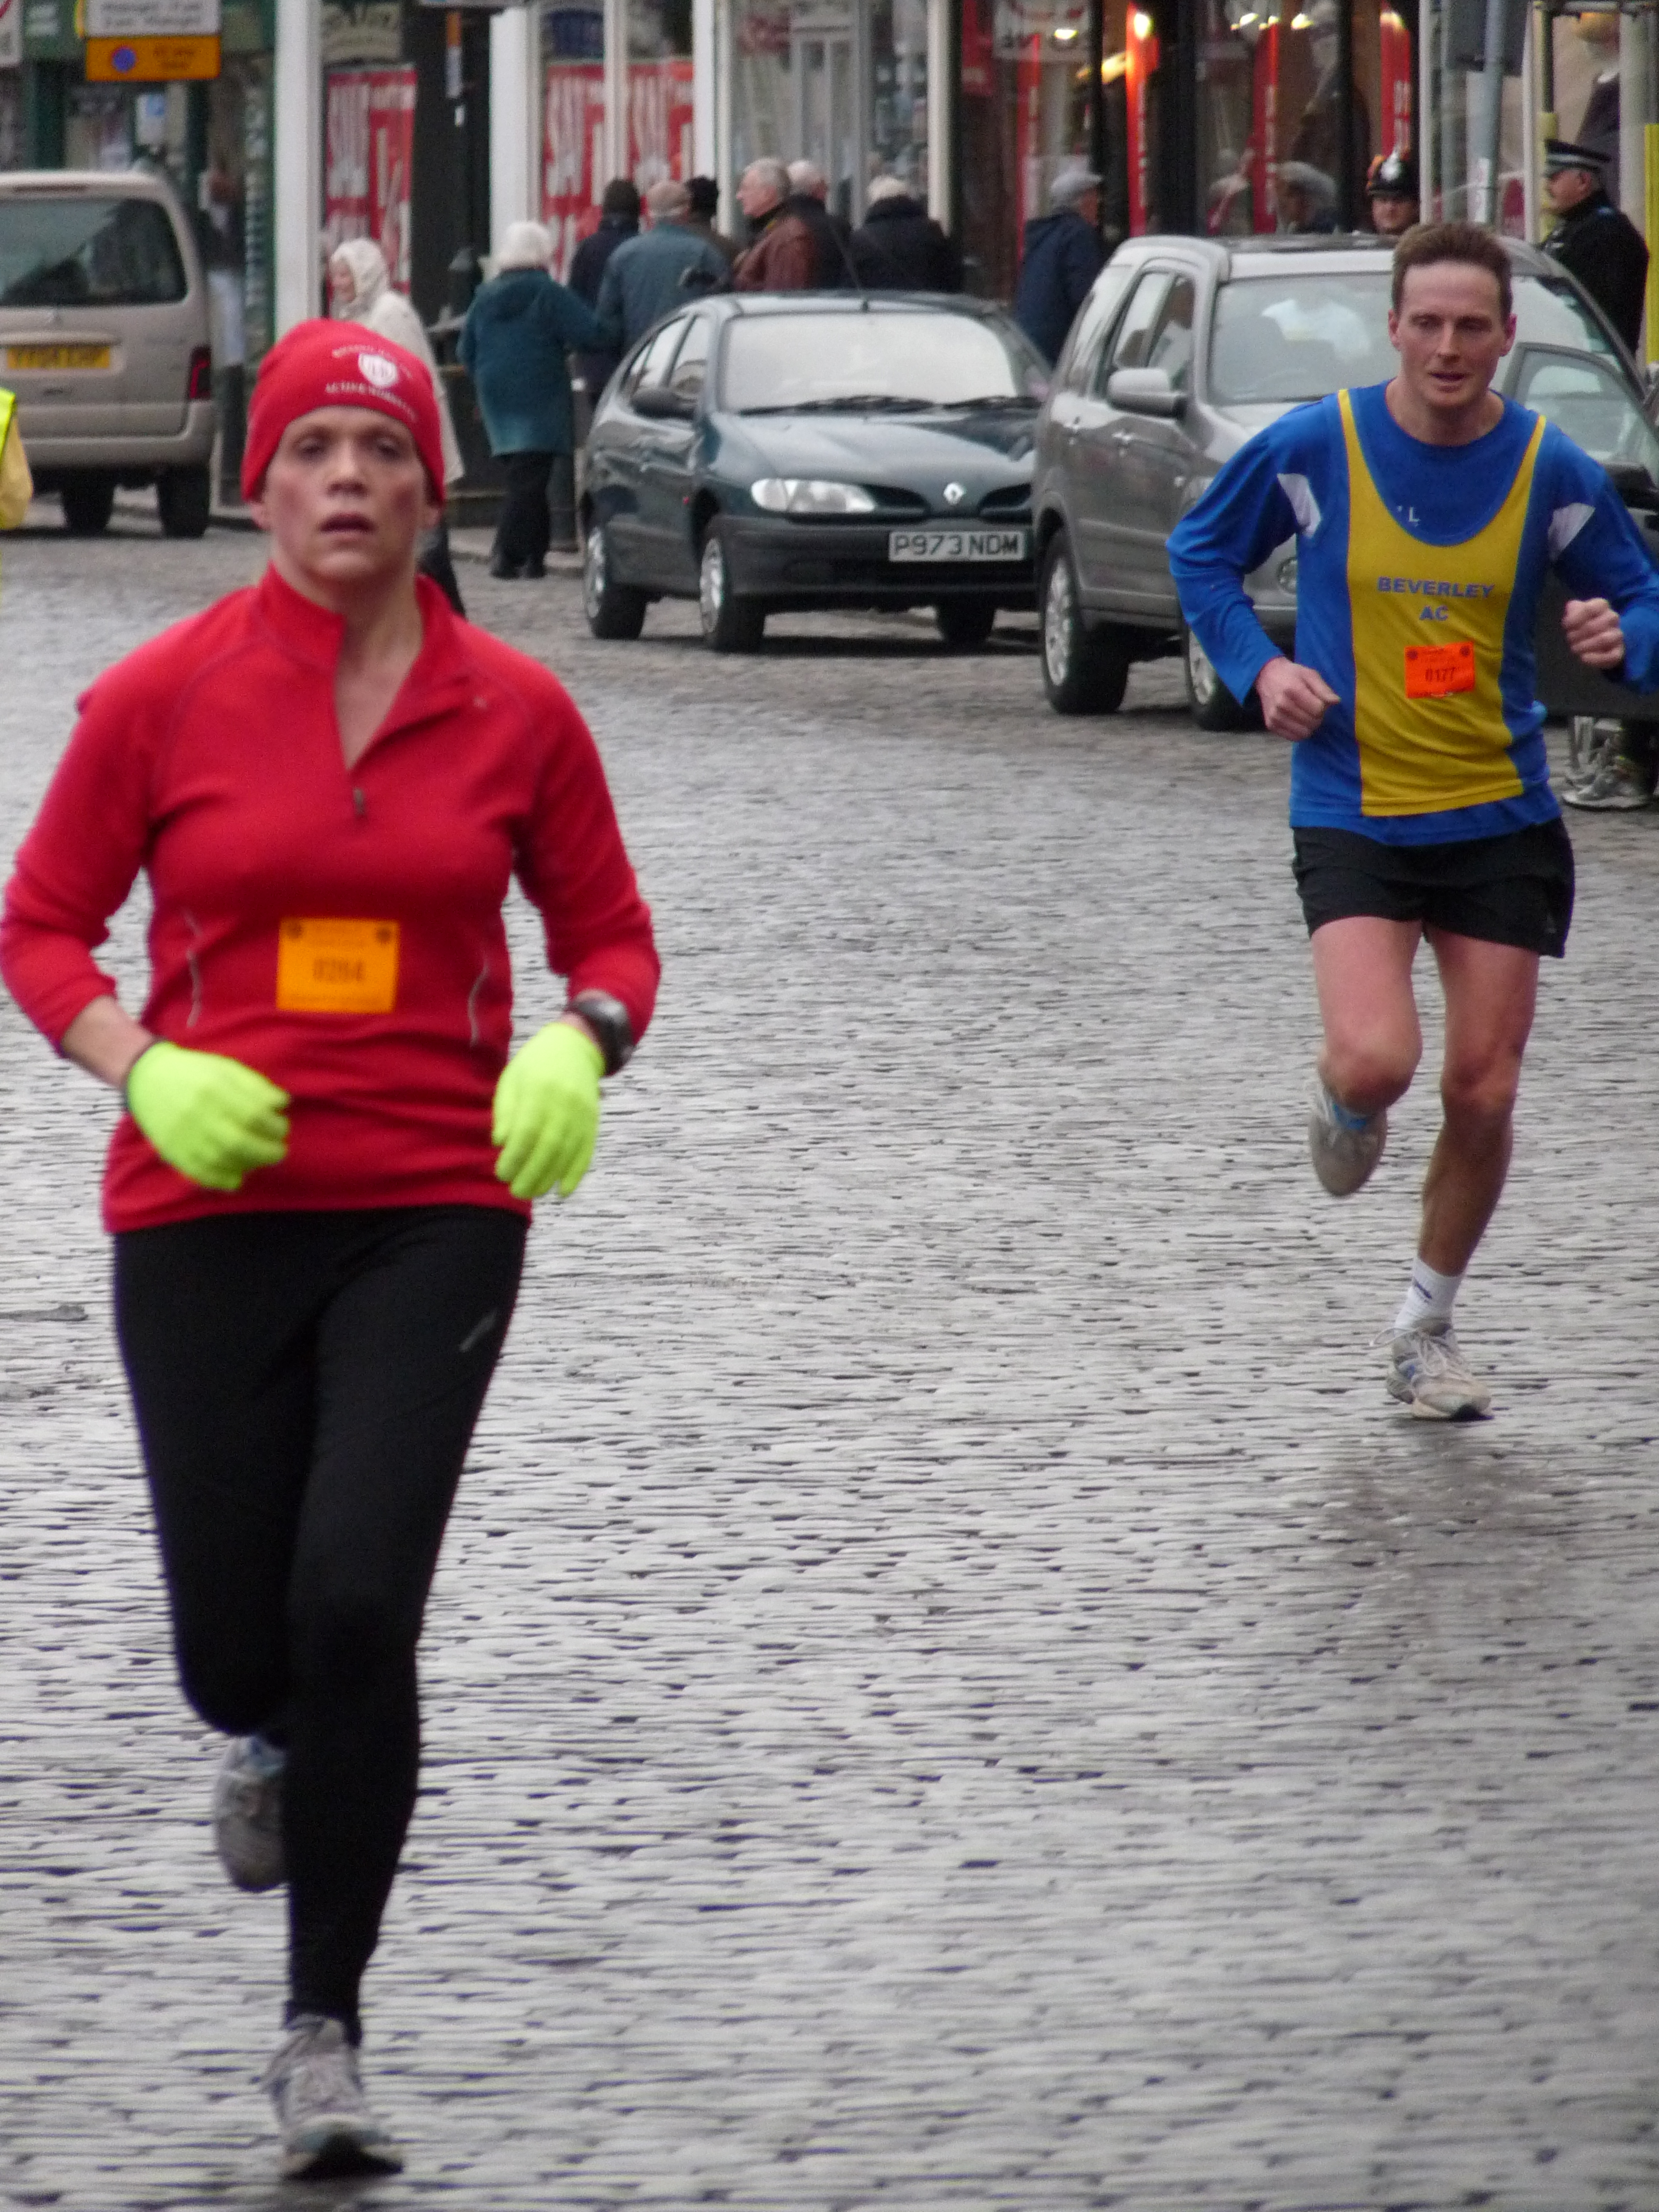
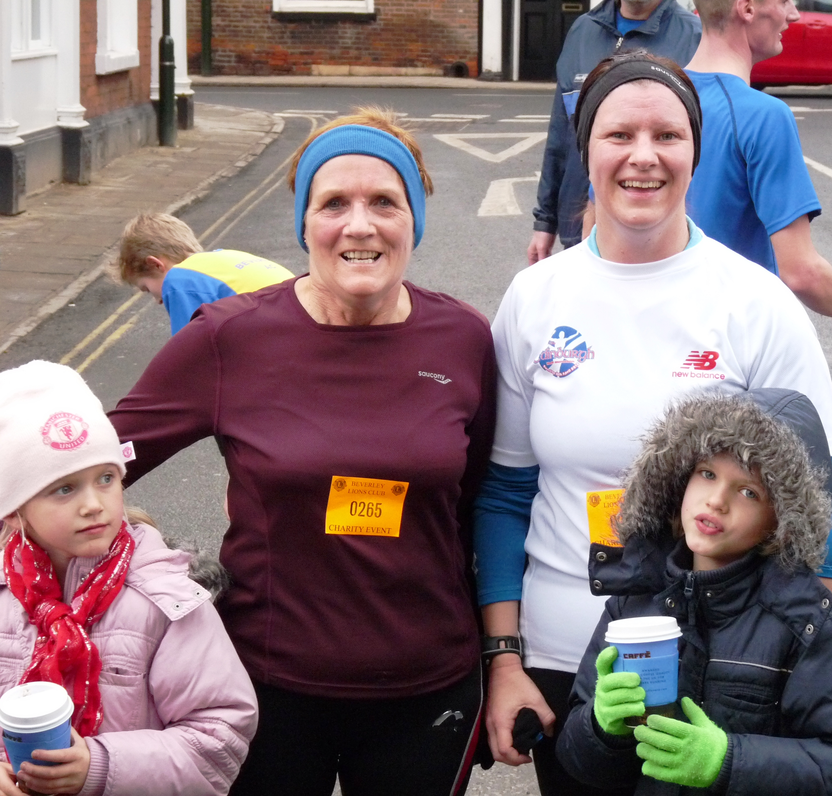
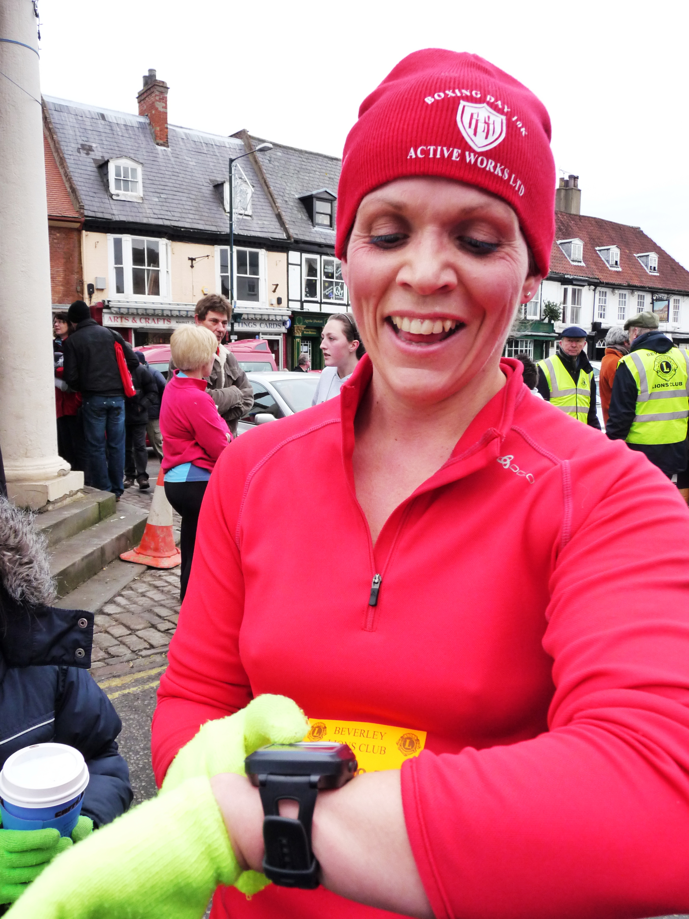
Beverley Lions
Fun Run

West Hull Ladies R.R.C Committee Meeting

Next Meeting:

Monday 7th February 2011

Muscle of the Month: Tibialis Anterior

Where is it?
It is located in the anterior (front) shin. It is attached to the tibia (main bone in the lower leg) and goes down the shin to attached underneath the mid foot.

What is it and what does it do?
It lifts up (dorsiflexes) the foot – an important action in running! It prevents the foot from slapping and dragging onto the ground after a heel strike, lifting the foot clear of the ground as it swings forward. It also inverts the foot i.e. it turns the sole of the foot inwards.


How does tibialis anterior get injured?
Through overuse generally. It is a fairly long, thin muscle, without too much power. It can over get overlooked in a stretching regime.

How can these be treated?
I treat tibialis injuries through deep frictions generally, as knots appear along the muscle belly that need to be broken down.

How do I stretch it?
Sit back on your heels with your back straight – this is probably the best way to stretch it.

How do I strengthen it?
Raising your toes off the ground and repeat for 3 sets of 20 will work the muscle.

Which muscle groups are related to it?
Tibialis posterior and the calf muscles (gastrocnemius and soleus). Also, the muscles supporting the arches underneath our feet.

Did you know....? It’s not an old wives’ tale – MUSCLE DOES WEIGH MORE THAN FAT!

About me
I am an Advanced Remedial Massage and Manipulative therapist based in Cottingham, Hull and Beverley. I treat a variety of sports people in my clinics and I am always delighted to treat members of the West Hull Ladies running club so if you would like to book an appointment or have any questions, you can email me at kirstieannskelton@hotmail.com, call 07789 914597 or visit my website www.kirstieannskelton.com for further details.

Treatment price change – a reminder
A reminder to everyone that as from 1st February, the charge per treatment will be £30. My general massage prices will rise to £32 as from 1 April 2011, but this will not affect members of the West Hull Ladies running club.

AmandaC’s Recipe: Thai Lime Chicken Stir-Fry


Like most Thai stir-fries, this recipe cooks up really quickly once you have all the ingredients ready. It features the flavor of lime - both lime juice and lime leaf. Lime leaves are an essential part of this stir-fry, so don't skimp on them. You can buy kaffir lime leaves at most Asian/Chinese food stores - look for them in frozen packets. This chicken stir fry also includes vegetables, so you get everything you need in one dish. Just serve with plain rice or noodles.

Prep Time: 15 minutes

Cook Time: 10 minutes

Total Time: 25 minutes

Yield: Serves 2-3

Ingredients:
- 3 chicken breasts, or 5-6 thighs, cut into strips or bite-size pieces
- 2 bell peppers (1 red, 1 green), chopped into bite-size pieces
- 1 small cooking onion, chopped or cut into thin wedges
- handful of fresh basil
- 2 Tbsp. canola or other vegetable oil for stir-frying
- a little white wine (or white cooking wine) for stir-frying
SAUCE:
- 3 spring onions, sliced
- 1 fresh red chili, or 1 tsp. chili sauce (add more or less according to your preference)
- 6-8 lime leaves, cut into strips with scissors (available frozen in Asian/Chinese food stores)
- 4 cloves garlic, minced
- 2 Tbsp. fish sauce (available in Asian/Chinese food stores)
- 2 Tbsp. lime juice
- 1/2 cup fresh basil
- 2 Tbsp. coconut, canola, olive, or other good-tasting and healthy oil
- 2 Tbsp. regular soy sauce
- 1 tsp. dark soy sauce (or 1/2 Tbsp. regular soy sauce)
- 1 tsp. brown sugar

Method:
- First, make the sauce by placing all sauce ingredients in a food processor or mini-chopper. When cutting the lime leaves, be sure to discard any inedible stems.
- Process well to form a thick sauce or paste (be sure to take a whiff of the wondrous smell of this concoction!). Set aside.
- Place 2 Tbsp. oil in a wok or large frying pan and set over medium-high heat. Add the onions and chicken.
- Stir-fry 6-8 minutes, or until chicken is well cooked. When stir-frying, add a little white wine (1 tbsp. at a time) whenever the wok/pan becomes too dry. This will keep the ingredients cooking nicely without having to add more oil (and fat/calories).
- Add the bell peppers, and stir-fry another 2-3 minutes, or until the bell pepper pieces have softened slightly and are bright in color.
- Turn heat down to minimum. Now add the sauce, stirring well to incorporate. Tip: Try not to fry or over-heat this sauce, or you'll lose all the great flavor and health benefits.
- Do a taste-test for salt and spice, adding more fish sauce if not salty enough, or more fresh chili (or chili sauce) if not spicy enough. If you prefer a "saucier" stir-fry, you can add a few Tbsp. of chicken stock, coconut milk, or cream.
- Tilt onto a serving dish, or portion out onto individual plates. Add a generous topping of fresh basil, and serve with either white or brown rice.

Timing is everything

Article from Women’s Running

The amount you eat at mealtimes should depend on the time of day you run. Whether you’re an early riser or an evening runner, here’s what should you be eating… and when. Words: Anita Bean


There’s no ‘best’ time of the day to run. Whether you choose to run first thing in the morning, during your lunch break or in the evening depends mainly on when you can fit it into your schedule. However, what and when you eat is closely connected to the time of day you run. People who run early in the morning will need a different nutritional plan to those who run at noon or in the evening. Here are some guidelines to ensure you have maximum energy, a fast recovery and no risk of weight gain, whatever time you don your trainers.

If you’re a morning runner
It’s tempting to think that running on an empty stomach first thing will burn more calories than running later in the day. While your body may burn slightly more fat than carbs after an overnight fast, it doesn’t mean you’ll lose more weight. Running burns calories no matter what the time of day, but running on empty may result in early fatigue and a lower calorie burn.

You should eat a light breakfast an hour or two before your run, although if you fall out of bed and straight into your trainers, a light snack will have to suffice. Early birds who can eat breakfast a few hours before their run should aim to take on 200 to 300 calories. Opt for high-carb foods that are low in fat – try cereal with fruit and skimmed milk, or wholegrain toast with honey.

Drink at least 250ml of fluid before your run, too.If you find eating this early a struggle, try a few bites of food, such as a cereal bar, energy gel, fruit yogurt or banana, with a glass of water. A small amount of carbs will make a big difference to your performance.

If you really can’t face food, have a nutritious drink, such as fruit juice (diluted with water), a smoothie, or a milk- or yogurt-based drink. This will provide energy to fuel your muscles, as well as fluid. After your run, it’s important to rehydrate and refuel. Drink 200 to 300ml straight away and then drink little and often throughout the morning. Eat within 30 minutes after your run.

Your post-run breakfast should supply around a quarter of your daily calories, carbohydrate, protein, vitamins, minerals and essential fats. A bowl of wholegrain cereal with nuts or seeds, fruit and milk would be suitable, as would wholegrain toast with poached eggs and tomatoes.

If you’re a midday runner
Running during your lunch break is a great way to fit exercise into your day, but if you don’t eat breakfast and a mid-morning snack, you can get hit with fatigue. First, make sure you have a healthy breakfast that will sustain you for three to four hours. Top choices include porridge with dried fruit and nuts, or wholegrain cereal with banana and yogurt. Second, bring a pre-workout snack to work. Eat this one to two hours before your run, to allow time for your food to digest. Good options include a wholegrain peanut butter sandwich, a flapjack or a fruit yogurt with a handful of nuts. Aim for around 200 calories, depending on what you had for breakfast (if you had a light breakfast, you may need a bigger snack).

Avoid high-fat foods within an hour of running, as these will make you feel lethargic. You’ll need to eat after your run to replenish your muscles’ glycogen stores. Be organised by bringing your lunch to work, so you can eat as soon as you finish your run. Sandwiches are a lunchbox mainstay – opt for wholegrain bread, pitta bread or bagels, and fill with high-protein foods, such as chicken, cheese, peanut butter or tuna, with salad for extra vitamins. Alternatively, take in a tub of cold pasta mixed with tomato sauce or pesto, some protein (such as chicken, tuna or nuts) and chopped veg. If you don’t have enough time for lunch, have a glass of fruit juice or a sports drink, and then eat healthy snacks throughout the afternoon, such as rice cakes, dried fruit and nuts.

If you’re an evening runner
If you run after work, you need to eat enough during the day to fuel your workout without overeating, to make sure you still have enough calories left in your daily allowance to refuel after your run. Aim to consume at least two-thirds of your daily calories in the meals and snacks eaten before your run.

Never skip breakfast and, ideally, make lunch your main meal of the day. Include a high-carbohydrate source, such as pasta or a baked potato, for sustained energy. Add lean protein, such as chicken, fish or eggs, along with vegetables or salad, and fresh fruit. If more than four hours elapse between lunch and your workout, you’ll need a pre-run snack for fuel. Plan a healthy, high-carb snack an hour before your run, which should supply 200 to 300 calories. Suitable snacks include six to eight dried apricots, one or two slices of wholegrain toast with honey, or two rice cakes with two teaspoons of peanut butter.

After your run, rehydrate with water, diluted juice or a sports drink – the latter two options being preferable if you’ve run for longer than 45 minutes. Always eat afterwards, no matter how late it is – your body needs carbohydrate and protein to replenish muscle fuel (glycogen) and aid recovery.

Many women worry that a late evening meal will turn to fat while they sleep, but this isn’t true. After exercise, your muscles convert carbohydrate to glycogen. The calories will turn to fat only if you overeat.

Try a stir-fry with chicken or tofu and wholegrain noodles (see recipe on p3), or a bean dish with wholegrain rice. Ideally, you should leave a few hours between your meal and going to bed, but if your running schedule doesn’t allow this, have a snack, such as a few slices of toast with peanut butter.

Race Write-Ups or Write-Offs:

McCain Yorkshire Coast 10km Road Race
Sunday 31st October 2010

KarenS: Having been injured for most of the summer months, the thought of getting back out running never mind racing was quite daunting.

I wasn’t expecting to take on a race until Boxing Day but a casual text from Geri to see if I was interested in the above was too good an opportunity to miss!
My mum was visiting for 2 weeks and I thought this would be good ‘practice’ for her and Georgia to come along and support me, so we drove to Scarborough making sure we had plenty of time to get from the Park & Ride to the start of the race. It was very straight-forward and easy to get to and from the start so a definite +point of the day.

Waiting for Geri and Nicola to arrive, I spotted a sporting legend – Sally Gunnell! Photo opportunity? She could only say no…and what a lovely person she is. It was great to have a chat with her and a group photo!

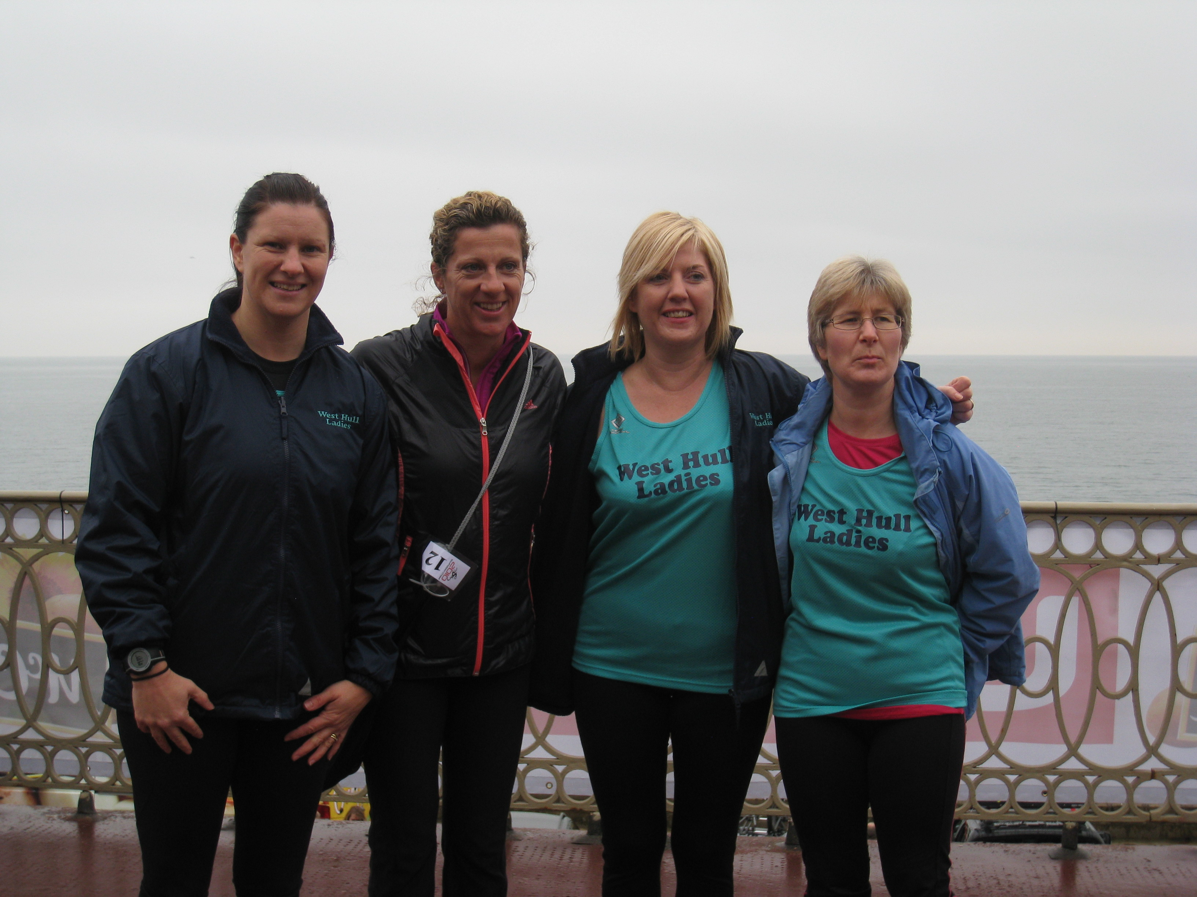
The race began and I set off too fast as usual – my family friend who is in his 60’s was there and I thought if I could keep him in my sights then I’d be alright. I really wanted to test my fitness and belief that I could get around the course in a good time. My first 2 miles were sub-9 min pace which is not me so I slowed down and settled into a pace in which I could keep up for the remainder of the run. (Yes I lost sight of my family friend who crossed the line in 50mins.)

The route was really scenic along the coastal road BUT seemed to go on forever on the way back. I found another runner to pace myself with for 5 minutes before steadily pushing myself onto the end. There was lots of support on route especially at the 1/5 mile markers and everyone running was really friendly and full of encouragement to keep going. The support in the last mile is just what you need to keep going and from somewhere I found a ‘burst’ of energy for the last stretch to the finishing line coming in with a pleasing time of 56mins and 32secs.

Geri and Nicola weren’t far behind, both crossing the line under the 1 hour mark. It was a great day out… ending with a visit to a fish and chip restaurant!

Would I run it again? Yes definitely. It’s down on my list of races for 2011 already!

East Hull Harriers Boxing Day 10k
Sunday 26th December 2010

KarenS: What can I say about this one? After a four and half week break from running I would say how stupid to start back with a race!

Well I woke that morning with no real urgency to get up and get ready. My hubby put paid to that. I was quite happy to roll over and go back to sleep but he made me get up…

Driving to the race, I started to get nervous. I questioned why I was doing it. It just seemed so wrong heading for a race with absolutely no preparation. This was totally the wrong attitude to have. I felt like I’d lost my motivation and enthusiasm for running but didn’t want to let on. It just shows you what a bit of bad weather can do to your morale.

I arrived and ‘ran’ down to the headquarters. This was the first race I was about to do for the second time and it then began to feel good that I’d turned up. There’s nothing like a race to help blow the cobwebs away. I was rather concerned I was the only West Hull lady there until Sharon appeared literally as the hooter was about to go!!

We started at the back, neither of us having trained since the evening the snow arrived. The route was good considering there had been fresh snow on Christmas Eve. The main roads were clear and even once we turned off; the roads were still clear not at all like last year’s icy conditions.

Once on the railway track, Sharon was in her element and took off. I didn’t have it in me to follow as even though it wasn’t slippery, the fresh snow made it hard work.

Getting back on the road was a good feeling. I was really struggling when I got to the last stretch. I knew I just had to get up the ‘hill’ and then it would be down hill from there. My hubby and daughter were at the finish line to cheer me in as always. The time was not the best but for me actually getting back out running was the best feeling!! It made me realise what I’d been missing for the past month.

The memento was lovely too - a red running top to go with my beanie hat from last year. I went home, got showered and wore it for the rest of the day!

Yes I will be there again next year…

Beverley Lions New Year’s Day Fun Run
Saturday 1st January 2011

Jo: After missing out on the Boxing Day 10k and with not having party plans for this New Year, I thought I’d blow away a few cobwebs by doing the Beverley Lions 6k Fun Run. There was an option of 3, 6 or 10k, but the 10k didn’t seem too appealing after such a lack of winter training and I was joined by my mum Kate and KarenS for the 6.
We lined up at the start behind a throng of Beverley AC Juniors and thought ‘oh no – beaten by kids!!’ It was an all road and pavement route and wonderfully with no snow or ice and soon had me lost in the maze of Beverley. Subsequently, with my knowledge of Beverley being limited, when I reached 6k and the market place finish was not in sight, I was feeling a little bemused and somewhat weary. When I finally finished, to see my mum and Karen waiting for me, I was certainly confused and as it turned out, a small group of the 6k runners had been sent on 8k!! This is the downside of having a GPS watch that tells you how far and how fast, yet doesn’t tell you to slow it down when you’ll be running for longer than expected!
Other than the marshalling mishap, it was a great little event, with a nice medal for finishing and I wouldn’t be put off doing it again. Maybe even the 10k next time round.

KarenS: This was a brilliant, no pressure event to start the New Year. I was planning to go to East Park to take part in the Park Run but Jo rung me up with plans to go to Beverley.

So I set off with Georgia to go and meet up with Jo, Kate, Jess, Ellie and Jo’s dad /Kate’s hubby (sorry I didn’t catch his name!). We had decided we were just going to enter the 6k distance as we were all a bit rusty (3k and 10k were on offer) – I’d run the past 2 days and Jo and Kate had been out the previous evening.

We lined up for the start of the ‘fun’ run with what seemed just the juniors from Beverley A.C. and we were off. Jo flew off round the corner, Kate went for it and I just followed thinking I only came for a bit of a jolly!

Jo disappeared into the distance and I finally caught up with Kate at the mile mark. At this point I do want to say I’d had a quick look at the route before we left and knew that we were just going to turn right every time we saw a marshal…

Kate and I got chatting – nothing new there! – about being able to get back out running and how much we’d missed it. I was feeling quite good and left Kate at about the 2 mile point knowing she wouldn’t be far behind me. A few of the 10k runners started to pass me at that point which motivated me to keep going as there weren’t that many runners to focus on in the distance.

I finally turned into the market area, towards the finish line and I could see Georgia and the girls cheering the runners in. It was a lovely surprise to see AmandaC there supporting her hubby who was running too.

I was chatting away to AmandaC when I suddenly realised there was no Jo. Where was she? Surely she’d finished? I looked around. The girls hadn’t seen her and I’d definitely not passed her on the way round. Kate came in very soon after me and still no sign of Jo. A few more minutes passed and it then became clear that a few runners had been sent on the wrong route, Jo being one of them! She finally arrived back having completed almost but not quite a 9k…

We all had a good giggle about it afterwards; it was just unfortunate a marshal had sent some of the 6k runners off on the 10k route.

I really enjoyed catching up with Jo, Kate and the girls. Georgia loves coming to support us and her bonus was drinking a lovely hot chocolate whilst waiting for us to finish.

My 4th run of the week! I’m gaining my motivation back and itching to get back to club. A great way to start the New Year and fingers crossed Georgia might want to run it next year. She has been talking about getting out and learning how to run so she can take part in more fun runs with Jess and Ellie as a West Hull Kid! Watch this space…

Racing and Running Events

2011 | Date | Time | Event | Distance | Fee | Website | Notes
Jan | 23rd | 10:00 | Brass Monkey | Half Marathon | N/A | www.yorkknavesmireharriers.co.uk | FULL
Jan | 30th | 11:00 | Ferriby | 10 miles | £10 | www.cityofhullac.co.uk | Online entry available
Feb | 27th | 11:00 | Snake Lane, Pocklington | 10 miles | N/A | www.pockrunners.com | FULL
Mar | 5th | 08:30 | Rudolph's Romp | 23 miles | £8  or £10 OTD | www.ldwa.org.uk | Rescheduled from Dec 2010
Mar | 20th | 10:00 | East Hull | 20 miles | £16 | www.easthullharriers.com | None
Mar | 27th | 11:00 | Thirsk | 10 miles | £14 | www.thirskandsowerbyharriers.co.uk | Rescheduled from Nov 2010
Apr | 3rd | 11:00 | Lincoln | 10K | £15 | lincoln10k.co.uk | Online entry available
Apr | 3rd | 11:00 | Hornsea | 1/3 marathon | £10 | www.hornseathirdmarathon.org.uk | Online entry available
Apr | 16th&  17th | 08:00 | The Woldsman Challenge Walk | 50 miles | £14 | www.ldwa.org.uk | None
May | 1st | 14:00 | Kirkbymoorside | 10K | £8 |  | Enter online at UKResults
May | 2nd | 09:30 | Rothwell | 10K | £12 or £15 OTD | www.rothwellharriers.org.uk | Enter online at UKResults
May | 8th |  | Beverley 10K | 10K |  | (not yet updated for 2011) | None
May | 8th | 09:30 | Sheffield | Half Marathon (Fun Run also) | £21 | www.sheffieldmarathon.com | Online entry available
** Dates/times are subject to change **

Keep checking the website for new races and updates at:

www.westhullladies.org.uk/races.htm

Verity, Racing Officer

NOTE: Club Vests must be worn at any races you enter
under the West Hull Ladies running club name.


Clubwear

PRICES:
Vest | £15.00 | All items are ordered on request and must  be paid for at time of ordering. To place an  order please get in touch via West  Hull Ladies e-mail and mark your emails  for the attention of Geri.
T- shirt | £16.50
Hoodie | £14.00
Jacket | £32



New Club Jacket available in three sizes: small, extra small, and junior (large fitting). If you would like to purchase one please send a cheque for £32 to Victoria Voase, Treasurer, and state on the back of your cheque your name and that the cheque is for a jacket.

Becca

Running Library

Using the library - Locker 18.
Choose your book, write your name and date on the card and leave the card in the locker so we know where the book is.
Book List:
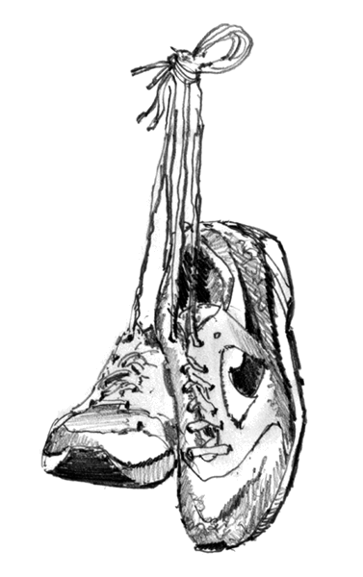
- The Runner's Diet (Runners World), Madelyn H. Fernstrom
- Paula My Story So Far, Paula Radcliffe
- Absolute Beginner's Guide to Half Marathon Training, Heather Hedrick
- The Runner's Handbook, Bob Glover
- The Competitive Runner's Handbook, Bob Glover & Shelly Lynn Glover
- Marathon Running For Mortals, John Bingham
- Marathon Running Beginner to Elite, Richard Nerurka

Running Magazines: These are available to borrow by emailing the club website.
Mark your email for the attention of Becca.

